DASHBOARDS

1.EXECUTIVE OVERVIEW
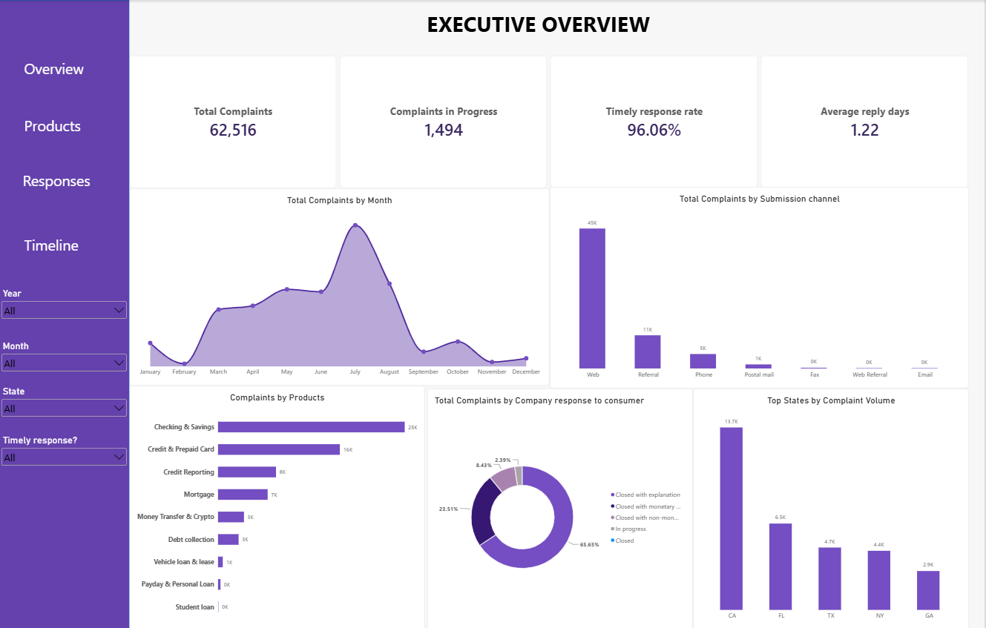

2. PRODUCT AND ISSUE ANALYSIS
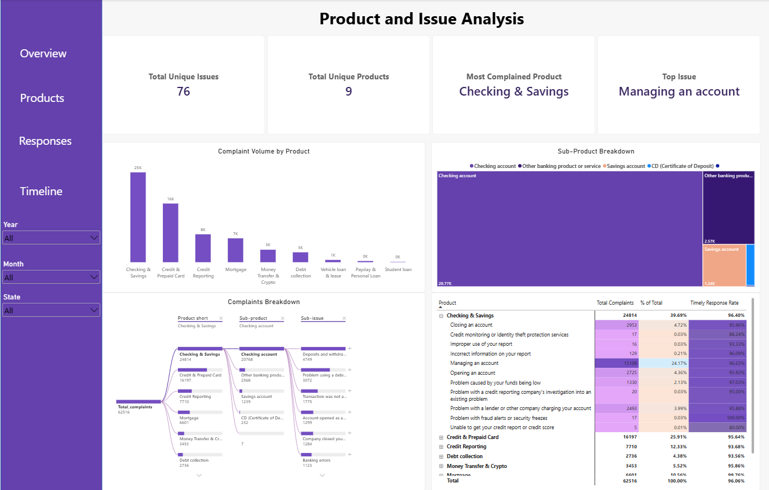
3. COMPANY RESPONSE ANALYSIS
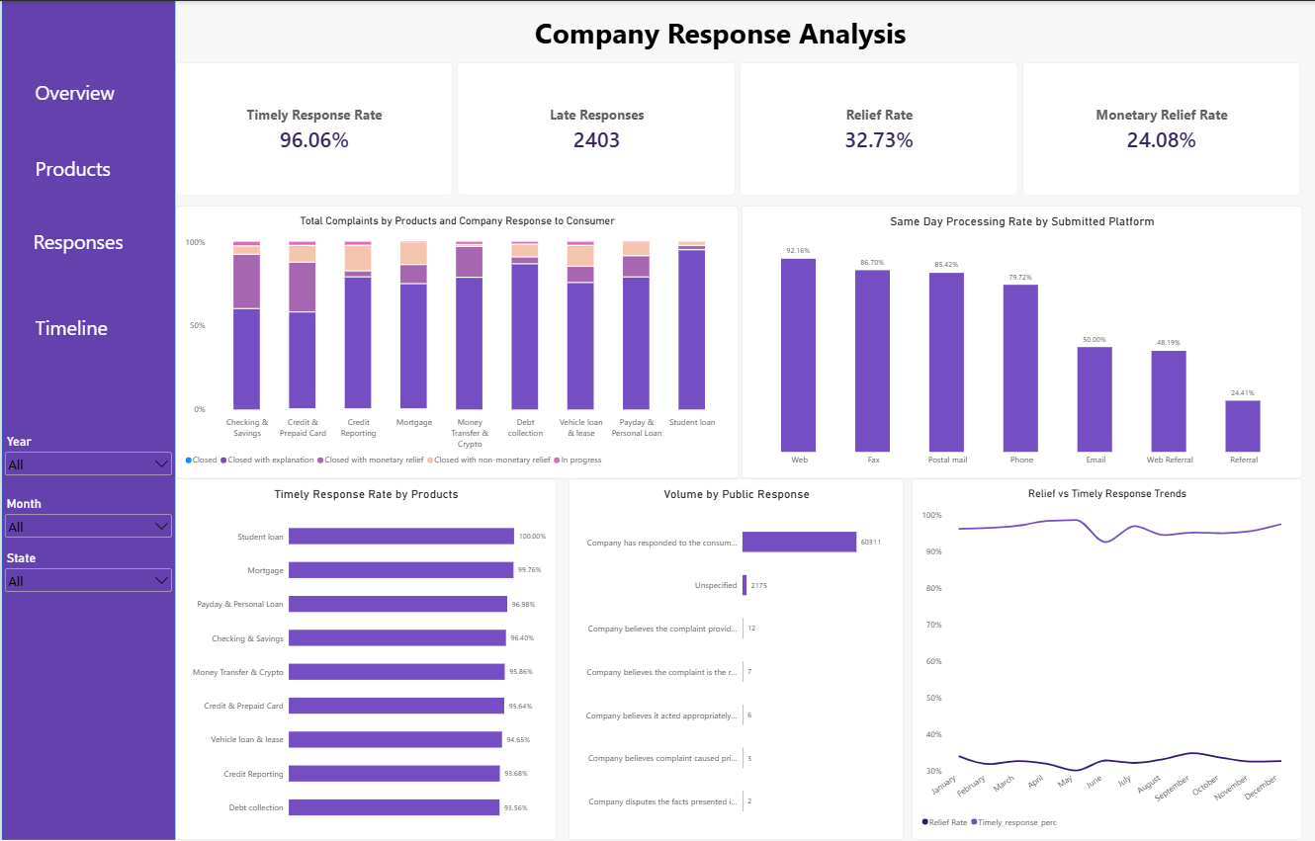

4. COMPLAINT TIMELINE ANALYSIS


